.

**DIRECT MOUNTED - TV3A**

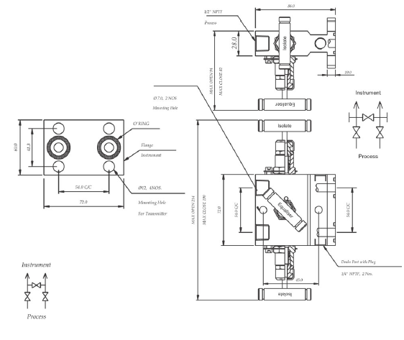

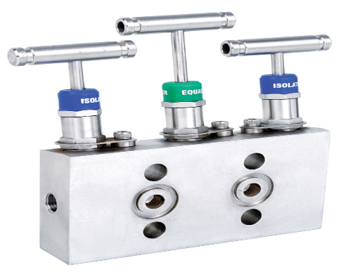

Product Name - TV3A - 3 Valve Directly Mounted

Product Description -

Directly Mounted 3 Valve Manifold.

Product Feature -

Working Pressure of 6000 psi.

Temperature rating up to 1200 deg F with optional Grapfoil packing.

Valves available in SS316/L and Exotic Alloys

Flange Seal Grooves meets the requirement of MSS SP 99.