.

**316 S.S. COMPRESSION FITTINGS**

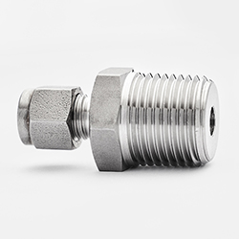

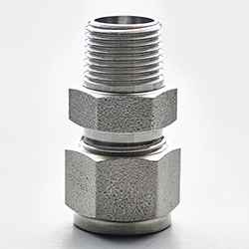

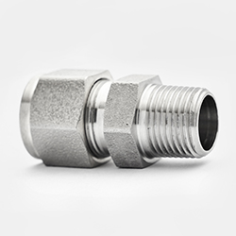

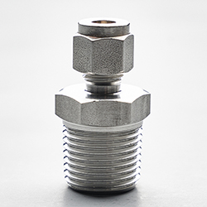

· Compression fittings are used for connecting metal tubes useful for high and low temperature applications ad compatibility with aggressive fluids these can be seen in systems varying from gas lines in refineries , to waste and water applications across all industries.

● **Non Magnetic Stainless Steel ● Sharp Threads for Proper Engagement to Prevent Leaks**

**● All CNC Machined, No Manual Polishing on Hex or Threads ● Bore Through, for Thermocouple Connector,**

**● 316 Stainless Steel per ASTM standards. ● Also avaliable in different Metal Alloys (Brass)**

CAD-CF2537SS

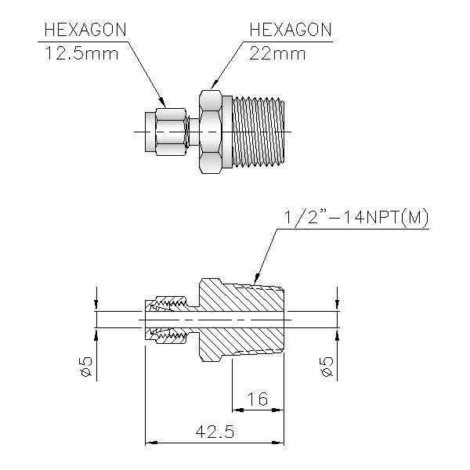

**SERIES SIZE**

**1) CF2537SS 1/4" NPT X 3/8" TUBE**

**2) CF3650SS 3/8" NPT X 1/2" TUBE**

**3) CF5018SS 1/2" NPT X 3/16" TUBE**

**4) CF3737SS 3/8" NPT X 3/8" TUBE**

**5) CF2525SS 1/4" NPT X 1/4" TUBE**

**6) CF3737SS 3/8" NPT X 3/8" TUBE**

**7) CF5050SS 1/2" NPT X 1/2" TUBE**

**8) CF2412SS 1/4" NPT X 1/8" TUBE**

CAD-2-CF5050SS

