Cast Iron standard thermocouple head with Silicone gasket and S. S. ball chain attached. Painted Silver. It can take either an elliptical or DIN style block.

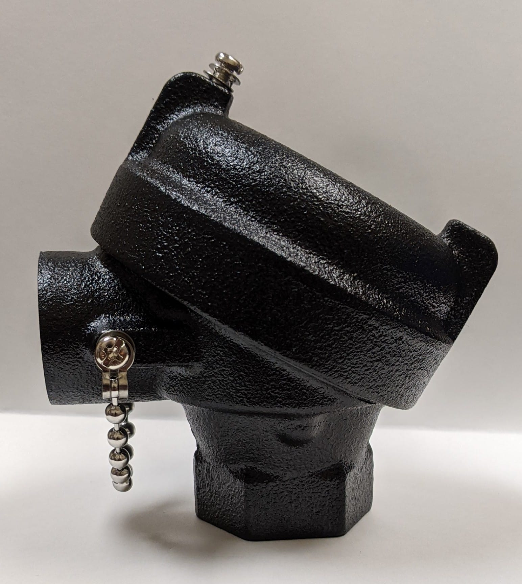

**PCL**

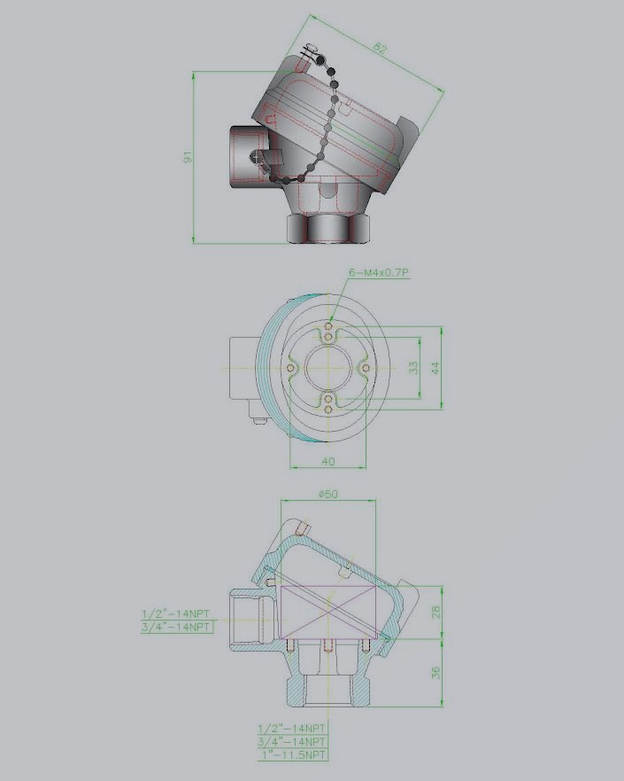

• PCL-01 3/4” X 1/2” NPT

• PCL-02 1/2” X 1/2” NPT*

• PCL-03 3/4” X 3/4” NPT

• PCL-04 3/4” X 1” NPT*

* These products require extra lead time.